Superstore Analysis:

January 2018 Net Margins

Tyrell Roberts

July 12, 2022

**Table of Contents**

1: Introduction 1

2: Analysis 2

2.1: Regions 2

2.2: Central 3

2.3: East 3

2.4: South 5

2.5: West 5

3: Conclusion 6

3:1 Recommendations 6

Appendix 8

**1. Introduction**

The data provided only contains information about revenue generation in the form of revenue and profit. Therefore, it cannot be unequivocally determined whether costs incurred represent COGS or are attributable to all business costs. Superstore has an overall profit margin of 12.47%. Based on ecommerce industry averages, gross margins of 30-45% and net margins of 5-10%, it is reasoned that costs represent all business costs. Therefore, the data and interpretation of it is based on net margin.

Figure 1 shows Superstore net margins by month, January 2018 presents a clear concern. It is a statistical outlier and represents the single largest monthly loss in a four-year period. This analysis digs through the various regions and states within them to identify the underlying causes of this loss, to ensure these results remain an aberration.

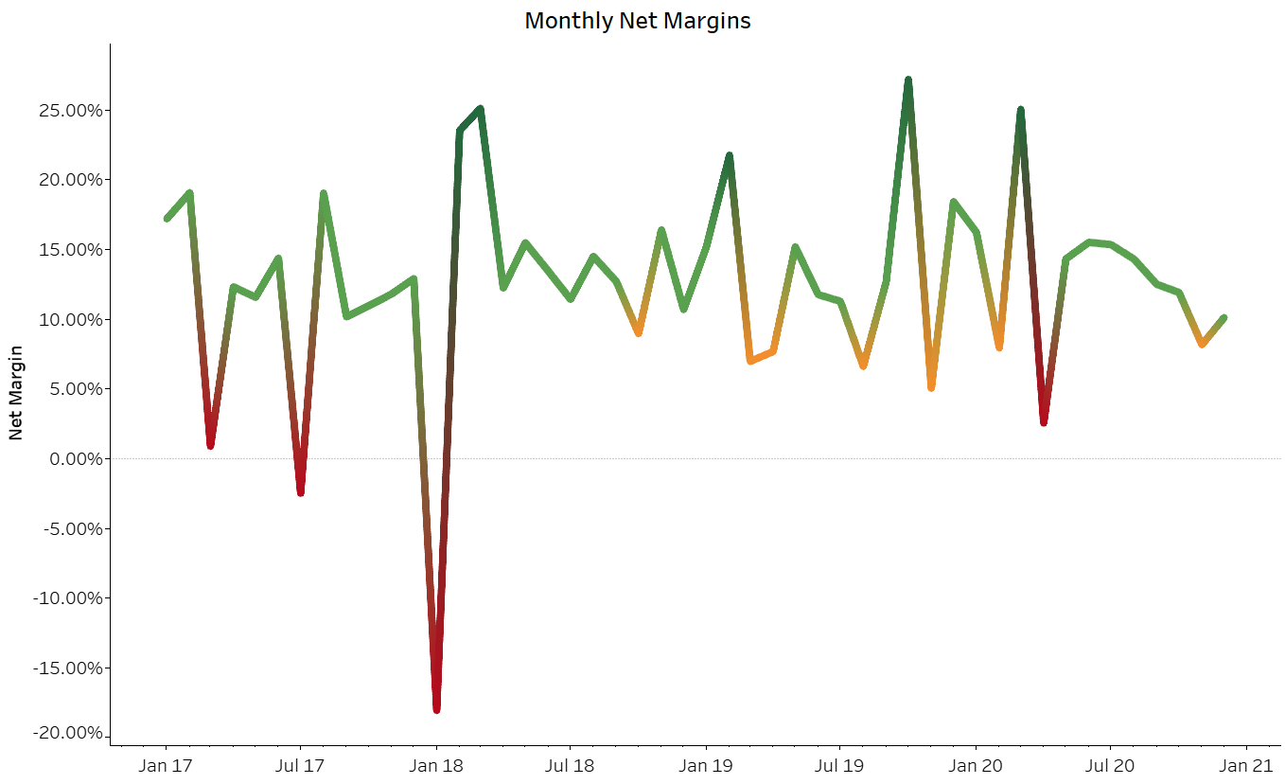 **Figure 1**: Line chart representing monthly net margins between 2017 and 2020. Green represents net margin at or above 10%, orange represents net margin below 10% but above 5%, and red represents net margin below 5%.

**2. Analysis**

2.1 Regions

Figure 2.1 displays net margin by region for the month of January 2018. In this figure it is clear that all regions performed below average with the only profitable region being the West with a net margin of 9.96%, just below the 10% benchmark. A portion of January 2018’s poor performance can be attributed to poor performance in January, overall, compared to other months. Over the four-year period, January is third worst in average net margin[1] and second worst in average revenue. However, net margin for the month of January in the other three years is positive so this can’t be the only cause.

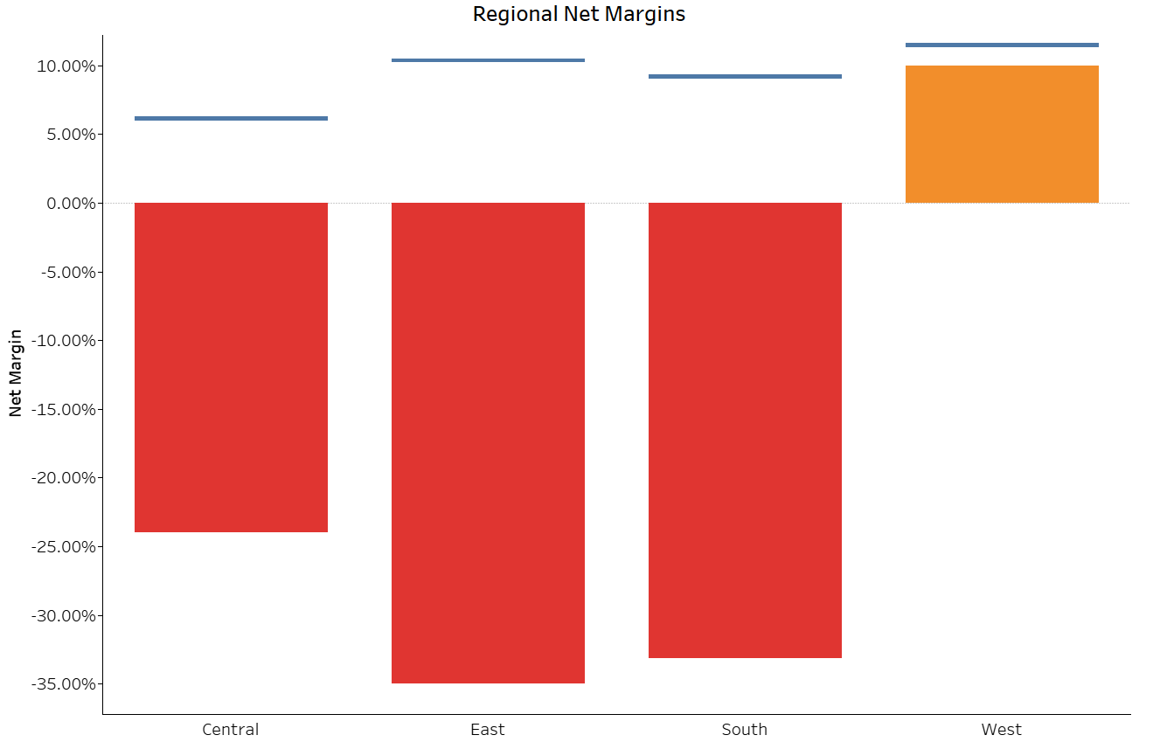

**Figure 2.1**: Bar chart representing regional net margins for January 2018. Blue lines represent average net margin for each region between 2017 and 2020.

2.2 Central

The Central region accounted for the smallest loss in January 2018, Figure 2.2 shows the net margin for Central states with sales that month. Transactions in Minnesota produced an excellent 43.37% net margin, but due to low sales in the area ($171.50) it did little to counteract losses from sales in Illinois and Texas. Sales in Illinois produced $254.74 of revenue with $312.06 of loss, all generated from the sale of seven chair mats at a 60% discount. Sales in Texas created $2,084.24 of revenue with $365.16 in losses. Losses in Texas mainly stemmed from the sale of nine bookcases at a 32% discount creating $437.54 of loss. Without these two sales, net margin for the region would have been 16.24%. Lower than average sales (IL -85%, MN -71%, TX -41%) combined with big losses greatly contributed to poor performance in the region.

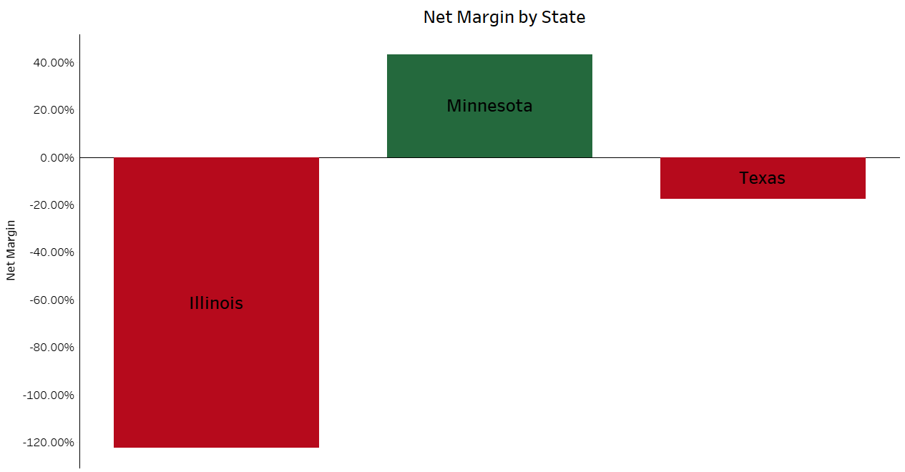

**Figure 2.2**:Bar chart displaying net margin for Central states with sales in January 2018.

2.3 East

The Eastern region accounted for the second highest loss in January 2018, Figure 2.3 depicts net margin for Southern states with sales that month. Net margins from Delaware and Massachusetts were good, but relatively low sales (DE - $580.51, MA - $6.67) in these areas did little to offset the large losses generated in New York and Ohio. Revenue from New York was $1,108.29 with $345.01 worth of losses. All losses in New York were from the sale of 4 conference tables at a 40% discount which created a loss of $373.30. Sales in Ohio generated $2,975.59 in revenue with $1,445.84 in losses. Losses in Ohio were due to various products within three transactions, but three of the products generated significantly more loss than the others. The largest loss came from the sale of nine video phones at a 70% discount resulting in a $950.40 loss. The second largest loss was a part of the same transaction, it came from the sale of five bookcases at a 50% discount creating a $244.32 loss. The third largest loss in Ohio came from the sale of 4 VoIP phones at a 40% discount and producing a loss of $100.79. Without these four-sales net margin for the region would have been 2.24%. Lower than average sales in New York and Massachusetts (NY -83%, MA -99%) and large losses on account of sizeable discounts were the main contributors of the Eastern region’s poor performance.

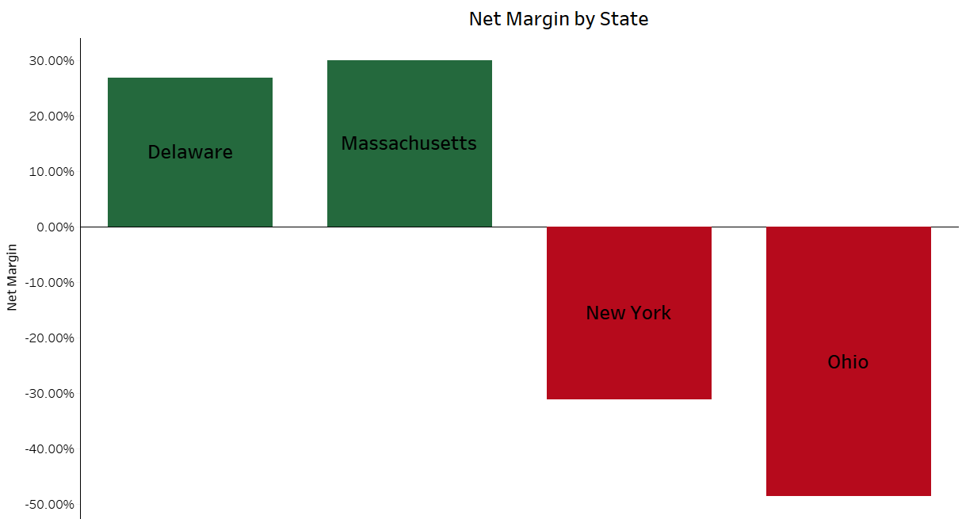

**Figure 2.3**:Bar chart displaying net margin for Eastern states with sales in January 2018.

2.4 South

The Southern region accounted for the largest loss in January 2018 and Figure 2.4 makes it clear that North Carolina was a major factor in the poor performance. All losses for the region came from one sale in North Carolina in which thirteen conference tables were sold at a 40% discount resulting in $1,862.31 of loss. Without this sale net margin in the Southern region would have been 32.51%. This single transaction in North Carolina was the only loss generator in the region, but drastically reduced sales in the other Southern states (FL -99%, GA -99%, KY -52%, TN -86%, VA -87%) also contributed to the overall poor performance of the region in January 2018.

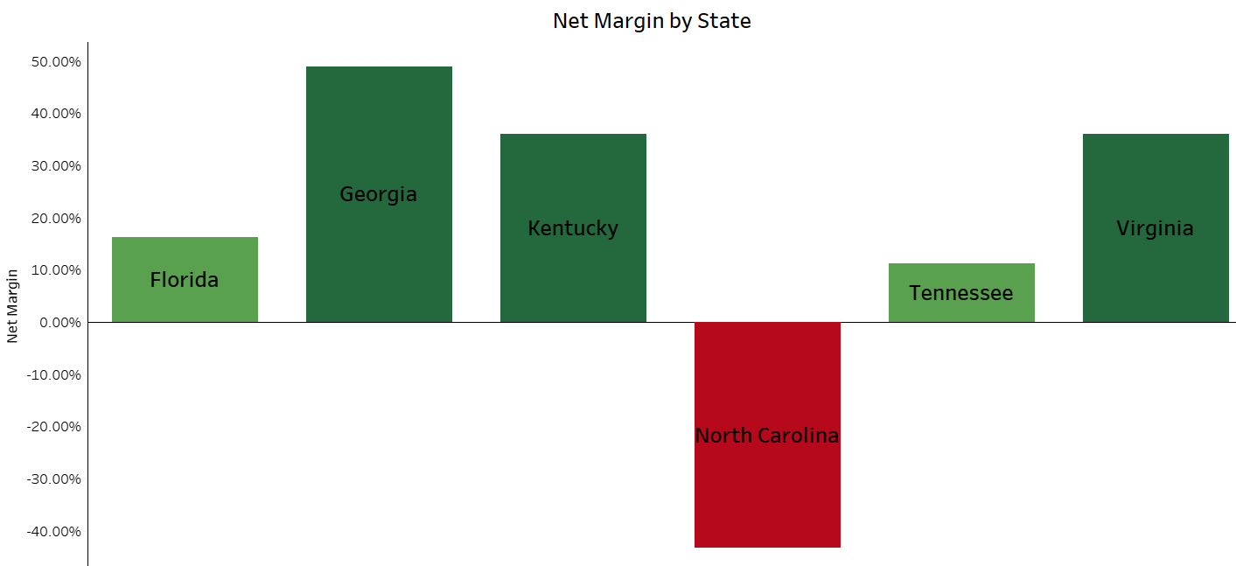

**Figure 2.4**:Bar chart displaying net margin for Southern states with sales in January 2018.

2.5 West

The Western region was the only profitable region during January 2018 and came in just below the 10% benchmark. In Figure 2.5 we see that Washington was the only state in the region to produce a loss, the loss was less than $7. California came in just below the 10% threshold due to the sale of 5 chairs at a 20% discount that generated no profit. Overall, the region suffered mostly due to below average sales (CA -38%, CO -95%, MT -63%, WA -98%).

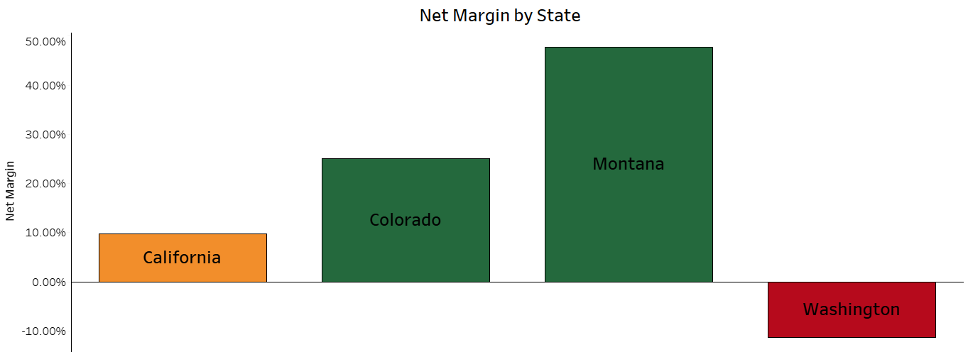 **Figure 2.5**:Bar chart displaying net margin for Western states with sales in January 2018.

**3. Conclusion**

The poor performance in January 2018 had two main culprits. With percent of average revenue for each region being Central 24%, East 33%, South 61%, and West 40% it is obvious that lack of sales was one of the issues. The second and more troublesome cause was large losses as a consequence of deep discounts. Due to the lack of data surrounding costs it can’t be determined how much of an impact they had on profit. Inventory data could have also been useful as it could have provided information about the origin of the discounts as well as potential cost reduction strategies. Although this is just one month, it provides insight into the potential ramifications of unchecked discounts.

3.1 Recommendations

Implementation of the following recommendations is the best course of action to diminish the probability of having another month like January 2018. They also allow deeper analysis in the future and the potential to develop best practices to ensure the companies continued success.

* Discount Tracking

All major losses incurred in January 2018 were the result of deep discounts. With no real way to discern why these discounts were provided it can’t be determined what, if any, benefit these provide to the company. Tracking discounts would prove highly beneficial when reviewing and analyzing previous months. It would provide knowledge about the nature of discounts, allowing for better analysis of the transaction, and would allow the advantages and disadvantages of discounts to be assessed.

* Discount Analysis

Based on current data, discounts greater than 20% should only be given in extreme circumstances. In the four years analyzed only thirty-two products sold with a discount larger than 20% were profitable, yet they made up almost 14% of items sold. Less than 19% of transactions with an average discount above 20% were profitable. On the other hand, over 94% of transactions with an average discount of 20% or less were profitable. A further analysis of discounts is recommended in order to determine the effect they have on sales as well as the optimal discount range.

* Cost Tracking

With the only access to cost data being through profit and sales it is impossible to make any recommendations on cost saving opportunities. Many of the losses incurred could have likely been diminished or eliminated through cost reductions in the supply chain. Tracking costs, specifically by the type of cost, is recommended to further enhance the company’s progress and development of top-tier cost management strategies.

**Appendix**

**Supplemental Figures**

Appendix Figure 1A: Average Net Margin by Month

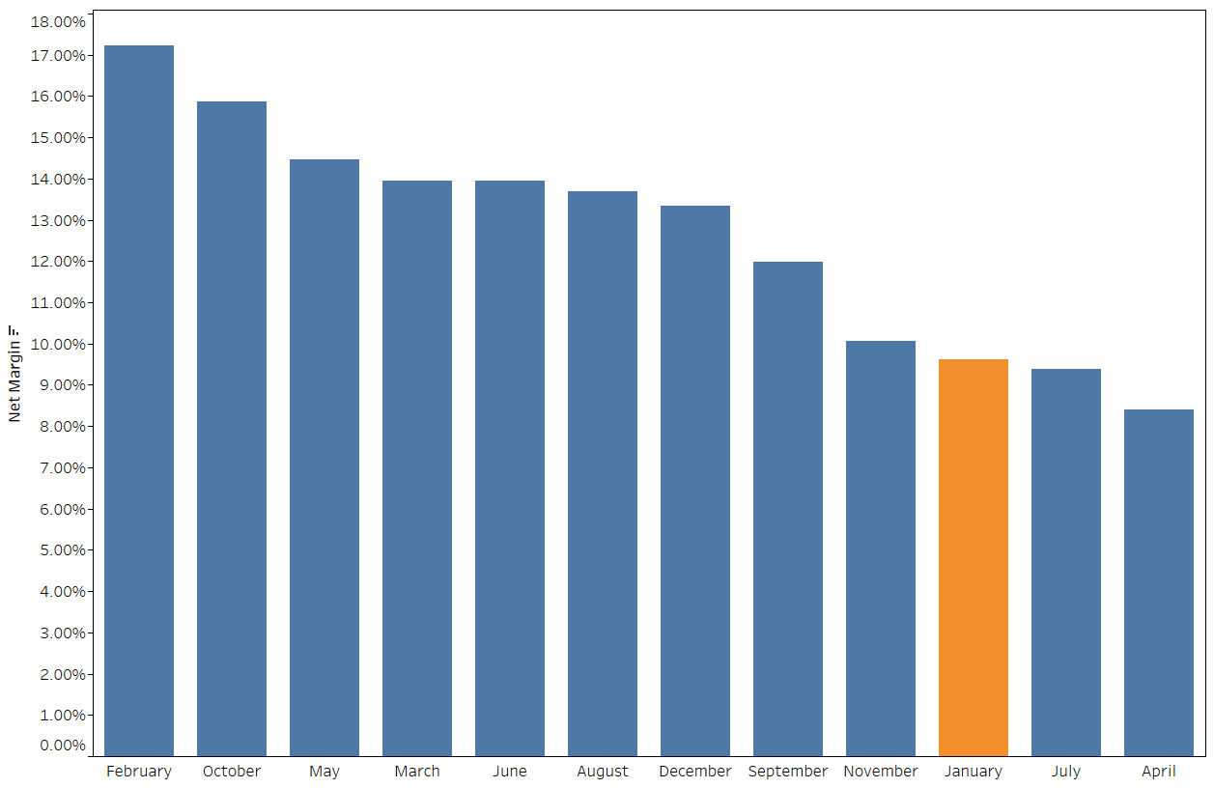

This figure displays average net margin (ordered highest to lowest) for each month between 2017 and 2020. The average was calculated using total profit over total revenue. January is highlighted for emphasis.

Appendix Figure 1B: Average Revenue by Month

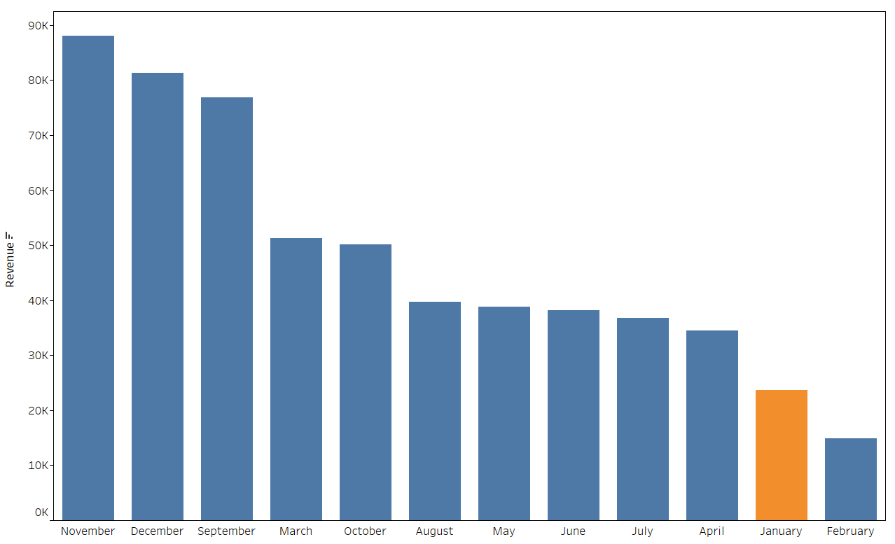

This figure displays average revenue (ordered highest to lowest) for each month between 2017 and 2020. The average was calculated using total revenue over total years (4) . January is highlighted for emphasis.

Appendix Figure 2: Monthly Revenue by State- January 2018 vs. Average

Central

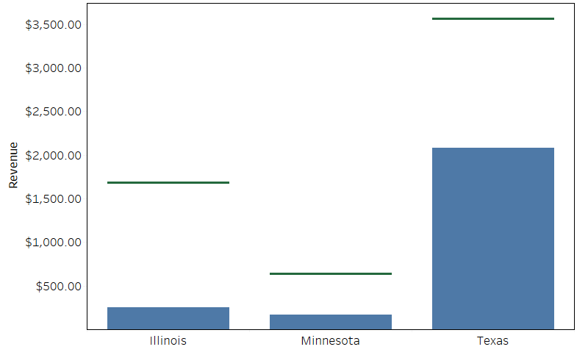

East

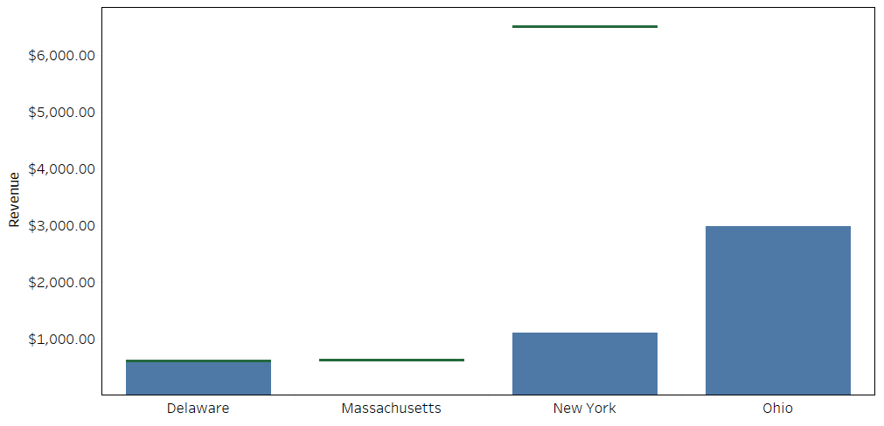

Note: In January 2018 revenue in Massachusetts was only $6.68, revenues in Delaware and Ohio surpassed their monthly averages.

South

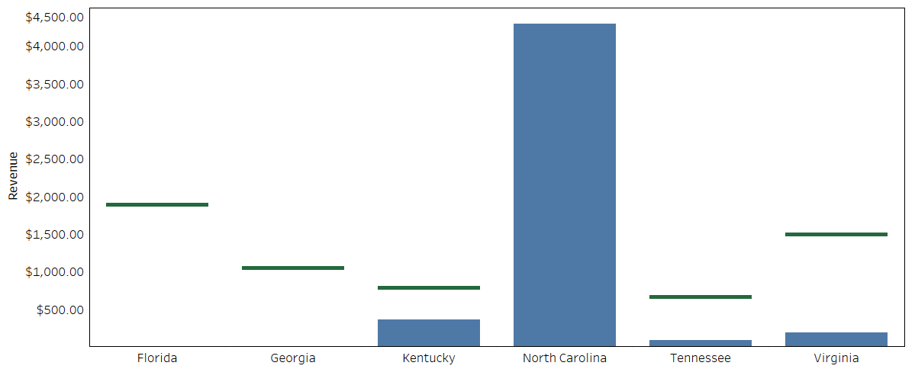

Note: In January 2018 revenues in Florida and Georgia were $13.12 and $9.82 respectively. Revenue in North Carolina surpassed the monthly average.

West

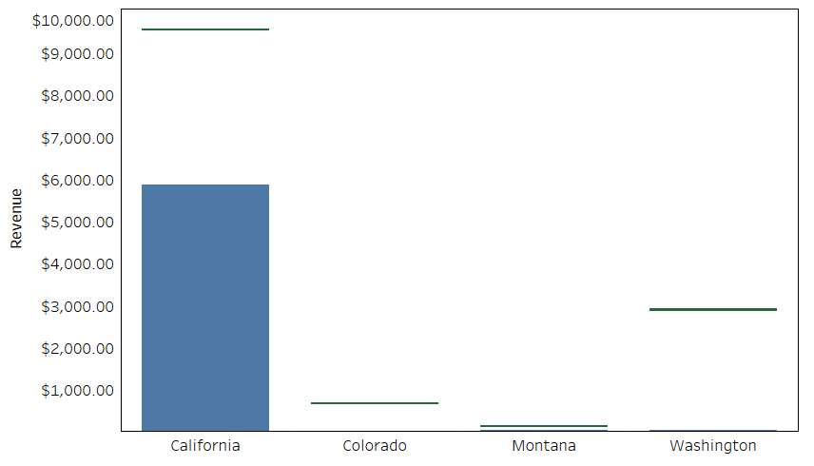

Note: In January 2018 revenues for Colorado, Montana, and Washington were $31.54, $43.66, and $61.58 respectively.

This figure represents the comparison of each states revenues in January 2018 and their average monthly revenue. The blue bars represent total revenue generated in January 2018 and the green lines represent average monthly revenue. Average monthly revenue was calculated as total revenue over total months (48).

Appendix Figure 3: Monthly Revenue by Region – January 2018 vs Average

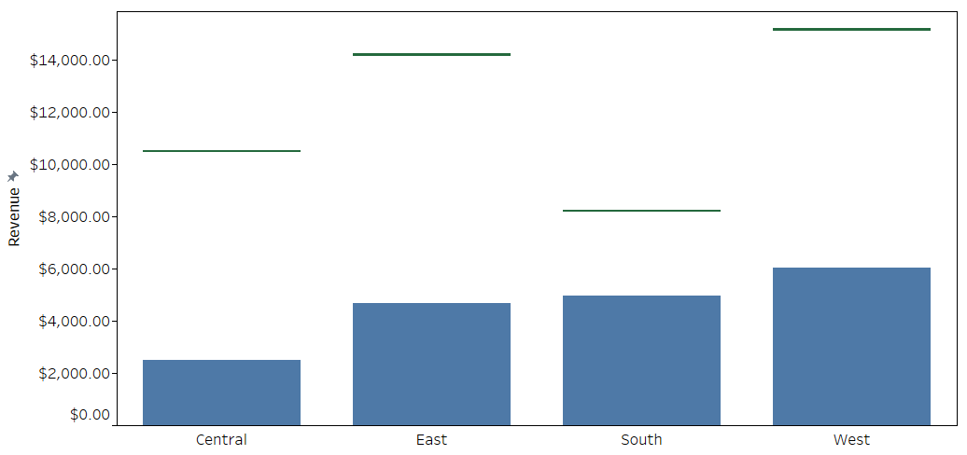



This figure represents the comparison of each regions revenues in January 2018 and their average monthly revenue. The blue bars represent total revenue in January 2018 and the green lines represent average monthly revenue. Average monthly revenue was calculated as total revenue over total months (48).

1. There isn’t enough data to determine if this would remain true over time, the extreme poor performance in 2018 and small sample size cause January data to be heavily skewed.